Requirement Document- AP

Prepared By : Swathi

Reviewed By : Alan, Gokul,Vasan

Proprietary Notice

The information contained in this document is of a proprietary nature. The disclosure, duplication, use in whole, or use in part, of the proposal for any purposes without the written permission of Logiware is prohibited.

Account Payable - Payments Screen

Given Layout Design:

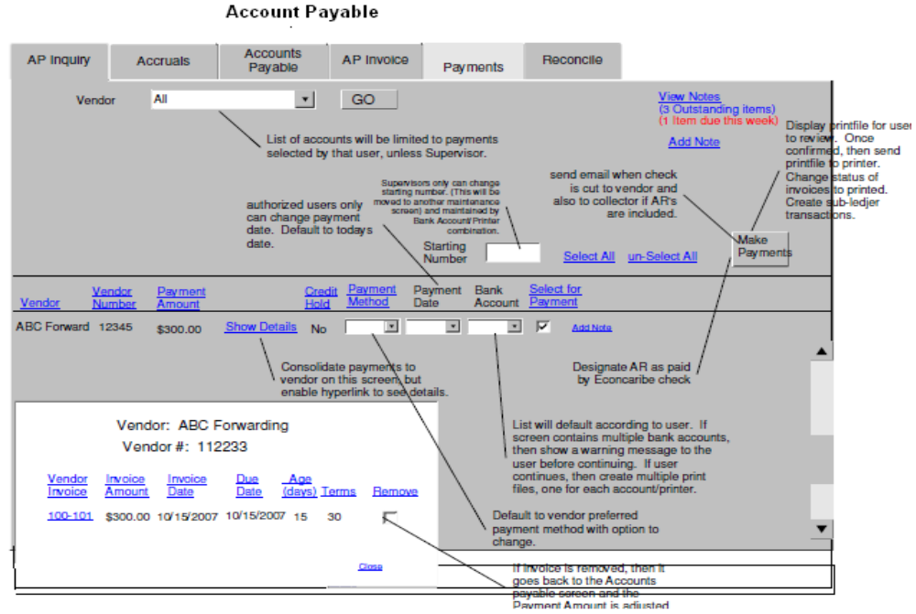

Clarification Required:
1.
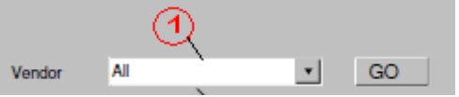
- Vendor should list names of all the Customers. These Customer names should be retrieved from Trading Partner table or from Transaction table based on any status specification.
It is mentioned in document that accounts will be limited based on payments selected by that user,unless the Supervisor. Need more clarification on this.
2.

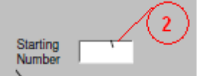
- What does the 'Starting Number' means and do this allows a manual entry by the user. Is this a part of searching the vendor before hitting the on GO button.

3.
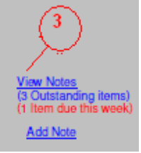
What is meant by 3 Outstanding items and 1 item due this week .Need more details.

4.

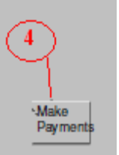
Three different functionalities are specified for the same button as follows :
(a).Printing the file
(b).Sending an email when check is cut to vandor and collector if AR's are added.
(c).Designating AR
- Need more details and the conditions to allow these actions permitted for the button mentioned.

5.
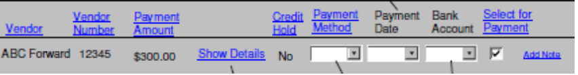

5(a).

- Onclick of this , should a pop up window opened displaying the vendor details for that particular vendor in list.
- Onclick of remove in this popup window,should the screen navigate to AccountsPayable screen literally ?
- Payment amount adjusted....??
Need more Details...

5(b).
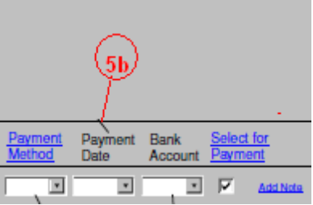
- Payment Method :What are the payment methods and vendor preffered default payment method.
Is it a selectbox or a regular textbox to allow user entry?
- BankAccount : Details not clear.
- Add Note : We already have AddNote and ViewNote in the screen , purpose of this again in the list ?
Need more Details on this.

